# 

# **Version Control Systems**

* **Version control systems are a category of software tools that help a software team manage changes to source code over time.**
* **Protects source code.**
* **It helps to fix mistakes.**
* **Different developers working in different parts of the code.**
* **Tracking every individual change by each contributor and helping prevent concurrent work from conflicting.**
* **Branching and Merging.**
* **Traceability, being able to trace each change made to the software.**

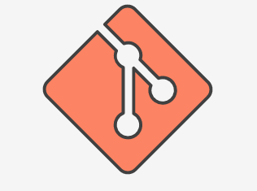

**GIT**

* **Distributed Version Control System Architecture.**
* **Different from CVS or SVN, full version history in one single place.**
* **In Git, every developer's working copy of the code is also a repository that can contain the full history of all changes.**
* [**https://www.atlassian.com/git/tutorials/what-is-version-control**](https://www.atlassian.com/git/tutorials/what-is-version-control)
* [**https://services.github.com/on-demand/downloads/github-git-cheat-sheet.pdf**](https://services.github.com/on-demand/downloads/github-git-cheat-sheet.pdf)

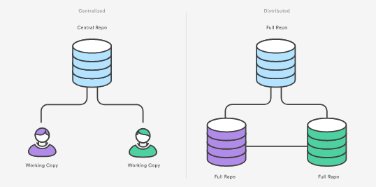

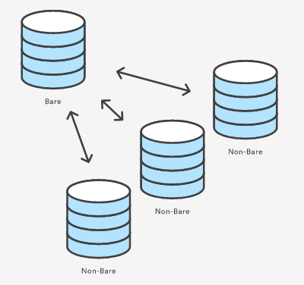

**Workflow**

